AWAITING THE NWAJIUBA PHENOMENON (7)

To recover Nigeria is a task that must be done.

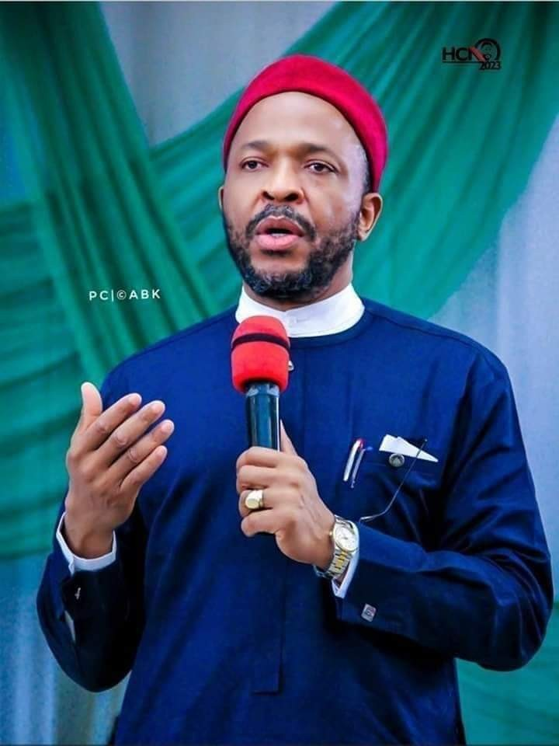
PASCHAL EGERUE.

At this critical point in our national history, we must do more of thinking of how to recover our country from economic stagnation and extinction than playing politics. What we need in the next dispensation is transformational leadership. Transactional leadership which reared its head in the military era and continues to be the means of political survival in Nigeria has brought ruin to all of us. Today, our budgeting circle and appropriation regime are purely transactional at all levels and no way near transformational. The Ministries, Departments and Agencies of Government and the legislators always think of what is in it for them both as individuals and as institutions. The mess created is what we often refer to as budget padding and shrinking done to satisfy personal or group choices rather than national development priorities. Any nation founded on lies and deceit will never develop and prosper. Our first task therefore is to elect a transformational leader as President of Nigeria in 2023. He will provide the leadership that will create the psychic momentum for all citizens to engage in the national recovery process. We need a President that will demonstrate commitment and positive influence. We want a President whose vision is easily embraced by all because it is visibly tied to the strategy for it's achievement. We want a President whose development action points and deliverables timelines are specified and accounted for. We want a President who will be decisive on crucial national issues and by that generate citizenship confidence, trust and optimism and which in turn will make grateful citizens to pay their taxes and do voluntarily,

other citizenship obligations and duties as stipulated in S.24(a-f) of the 1999 Constitution of the Federal Republic of Nigeria (as amended).
Nigeria by share size of land mass, mineral endowment and population is a potentially great country. It is sad that 61 years after independence, we are still talking about our dear country in terms of potentiality and not the full realization of nationhood. The demographic dynamics of the nation is skewed to youthful vibrant population. This gives hope that with the right leadership and strategy, Nigeria will be great again. What we need essentially is to align planning horizon to the vision of the leader. Ad-hocism in national planning matters has wrecked havoc on this nation. The first Republic was able to thrive because it was predicated on longer development planning horizon of four years minimum. Our present Medium Term Expenditure Framework (MTEF) on which the nation's annual budget is based is very fixated on past year performance in fixing current year budget figures. In a nation plagued by dismal budget performance, budget deficit and the burden of escalating recurrent expenditure, this is an invitation to disaster. An exhaustive rethinking of our yearly development plan(budget) strategy is therefore imperative. Hon( Dr) Emeka Nwajiuba's Presidency come 2023 has the greatest prospect of putting back this nation - Nigeria on the path of sustainable economic development. The APC delegates at the next convention have a national and indeed highly patriotic duty to elect Dr Emeka Nwajiuba in the primaries as the flag bearer of APC in the 2023 Presidential Election. He has consistently shown strength of character and industry. He has served the party and the nation loyally without blemish. As a key member of the strategy room of CPC, he was a central person in midwifing the Present APC and indeed was a leading figure in drafting the Constitution of APC based on which the merger of CPC with ACN to form APC was achieved. Hon(Dr)Emeka Nwajiuba has paid his dues. As a mark of his faith in Nigeria and his seriousness and readiness for this Presidential project, he was the first contestant to obtain his nomination form and the first to resign from his Ministerial position. The accolade he got on this feat from no other person than Mr President speaks volumes of this emerging phenomenon. Writing independently, Mr Dialoke, a Lagos based public policy analyst and researcher on transformational leadership has this to say of Hon(Dr) Emeka Nwajiuba - "From his antecedents, and given his verve, acumen, industry, resilience and patriotism, the indications are that the nation will hear more from Nwajiuba in the not distant future as it is hoped that he will join hand with his other compatriots to build a better Nigeria".
Paschal Egerue is a Lagos based Insurance and Management Consultant.

